**Experiment No:** 01 [Example 2.1(a)]

**Name of Experiment:** Generate and Plot

|  |  |
| --- | --- |
| Program Code:  function [x,n] = impseq(n0,n1,n2)  n = [n1:n2]; x = [(n-n0) == 0];  clc;  clear;  close all;  n = [-5:5];  x = 2*impseq(-2,-5,5) - impseq(4,-5,5);  stem(n,x);  title('Sequence in Problem 2.1a');  xlabel('n');  ylabel('x(n)'); | Output: |

**Experiment No:** 02 [Example 2.1(b)]

**Name of Experiment:** Generate and Plot

|  |  |
| --- | --- |
| Program Code:  function [x,n] = stepseq(n0,n1,n2)  n = [n1:n2]; x = [(n-n0) >= 0];  n = [0:20];  x1 = n.*(stepseq(0,0,20)-stepseq(10,0,20));  x2 = 10*exp(-0.3*(n-10)).*(stepseq(10,0,20)-stepseq(20,0,20));  x = x1+x2;  subplot(2,2,3);  stem(n,x);  title('Sequence in Problem 2.1b');  xlabel('n');  ylabel('x(n)'); | Output: |

**Experiment No: 03** [Example 2.1(c)]

**Name of Experiment:** Generate and Plot

|  |  |
| --- | --- |
| Program Code:  n = [0:50];  x = cos(0.04*pi*n)+0.2*randn(size(n));  subplot(2,2,2);  stem(n,x);  title('Sequence in Problem 2.1c');  xlabel('n');  ylabel('x(n)'); | Output: |

**Experiment No:** 04 [Example 2.1(d)]

**Name of Experiment:** Generate and Plot

|  |  |
| --- | --- |
| Program Code:  n = [-10:9];  x = [5,4,3,2,1];  xtilde = x' * ones(1,4); xtilde = (xtilde(:))';  subplot(2,2,4);  stem(n,xtilde);  title('Sequence in Problem 2.1d');  xlabel('n');  ylabel('xtilde(n)'); | Output: |

**Experiment No:** 05 [Example 2.2 (a, b)]

**Name of Experiment:** Determine and Plot, Let

|  |  |
| --- | --- |
| Program Code 2.2(a):  function [y,n] = sigadd(x1,n1,x2,n2)  n = min(min(n1),min(n2)):max(max(n1),max(n2));  y1 = zeros(1,length(n)); y2 = y1;  y1(find((n>=min(n1))&(n<=max(n1))==1))=x1;  y2(find((n>=min(n2))&(n<=max(n2))==1))=x2;  y = y1+y2;  function [y,n] = sigshift(x,m,k)  n = m+k; y = x;  n = -2:10;  x = [1:7,6:-1:1];  [x11,n11] = sigshift(x,n,5);  [x12,n12] = sigshift(x,n,-4);  [x1,n1] = sigadd(2*x11,n11,-3*x12,n12);  subplot(2,1,1);  stem(n1,x1);  title('Sequence in Example 2.2a');  xlabel('n');  ylabel('x1(n)'); | Program Code 2.2(b):  function [y,n] = sigadd(x1,n1,x2,n2)  n = min(min(n1),min(n2)):max(max(n1),max(n2));  y1 = zeros(1,length(n)); y2 = y1;  y1(find((n>=min(n1))&(n<=max(n1))==1))=x1;  y2(find((n>=min(n2))&(n<=max(n2))==1))=x2;  y = y1+y2;  function [y,n] = sigshift(x,m,k)  n = m+k; y = x;  function [y,n] = sigmult(x1,n1,x2,n2)  n = min(min(n1),min(n2)):max(max(n1),max(n2));  y1 = zeros(1,length(n)); y2 = y1;  y1(find((n>=min(n1))&(n<=max(n1))==1))=x1;  y2(find((n>=min(n2))&(n<=max(n2))==1))=x2;  y = y1 .* y2;  function [y,n] = sigfold(x,n)  y = fliplr(x); n = -fliplr(n);  [x21,n21] = sigfold(x,n);  [x21,n21] = sigshift(x21,n21,3);  [x22,n22] = sigshift(x,n,2);  [x22,n22] = sigmult(x,n,x22,n22);  [x2,n2] = sigadd(x21,n21,x22,n22);  subplot(2,1,2);  stem(n2,x2);  title('Sequence in Example 2.2b');  xlabel('n');  ylabel('x2(n)'); |

Output:

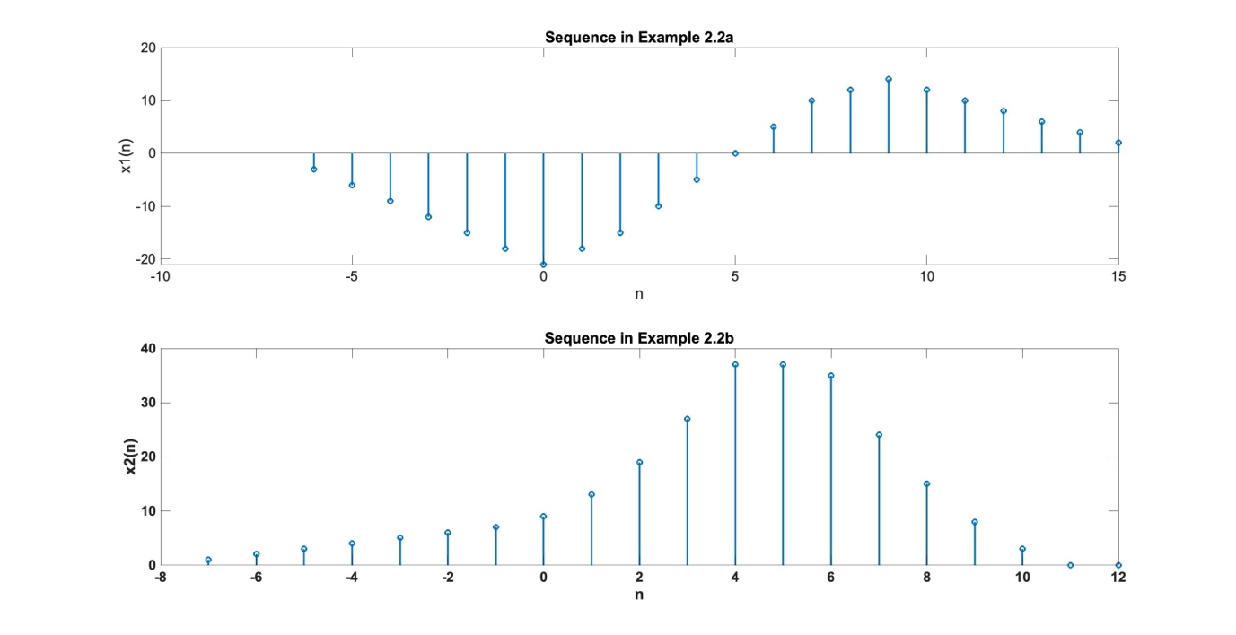

**Experiment No:** 06 [Example 2.3]

**Name of Experiment:** Generate the complex-valued signal

|  |  |
| --- | --- |
| Program Code:  clc;  clear;  close all;  n = [-10:1:10];  alpha = -0.1+0.3j;  x = exp(alpha*n);  subplot(2,2,1);  stem(n,real(x));  title('real part');  xlabel('n');  subplot(2,2,2);  stem(n,imag(x));  title('imaginary part');  xlabel('n');  subplot(2,2,3);  stem(n,abs(x));  title('magnitude part');  xlabel('n');  subplot(2,2,4);  stem(n,(180/pi)*angle(x));  title('phase part');  xlabel('n'); | Output: |

**Experiment No:** 07 [Example 2.4]

**Name of Experiment:** **Let** *x(n) = u(n) - u(n - 10).* Decompose c(n) into even and odd components.

|  |  |
| --- | --- |
| Program Code:  function [x,n] = stepseq(n0,n1,n2)  n = [n1:n2]; x = [(n-n0) >= 0];  function [xe, xo, m] = evenodd(x,n)  if any(imag(x) ~= 0)  error('x is not a real sequence')  end  m = -fliplr(n);  m1 = min([m,n]); m2 = max([m,n]); m = m1:m2;  nm = n(1)-m(1); n1 = 1:length(n);  x1 = zeros(1,length(m)); x1(n1+nm) = x; x = x1;  xe = 0.5*(x + fliplr(x)); xo = 0.5*(x - fliplr(x));  n = [0:10];  x = stepseq(0,0,10)-stepseq(10,0,10);  [xe,xo,m] = evenodd(x,n);  subplot(2,2,1);  stem(n,x);  title('Rectangular pulse');  xlabel('n');  ylabel('x(n)');  axis([-10,10,0,1.2]);  subplot(2,2,2);  stem(m,xe);  title('Even Part');  xlabel('n');  ylabel('xe(n)');  axis([-10,10,0,1.2]);  subplot(2,2,4);  stem(m,xo);  title('Odd Part');  xlabel('n');  ylabel('xe(n)');  axis([-10,10,-0.6,0.6]); | Output: |

**Experiment No:** 08 [Example 2.5]

**Name of Experiment:** Let the rectangular pulse *x(n) = u(n) - u(n - 10)* of Example 2.4 be an input to an LTI system with impulse response Determine y(n).

|  |  |
| --- | --- |
| Program Code:  function [x,n] = stepseq(n0,n1,n2)  n = [n1:n2]; x = [(n-n0) >= 0];  n = -5:50;  u1 = stepseq(0,-5,50); u2=stepseq(10,-5,50);  x = u1-u2;  h = ((0.9).^n).*u1;  subplot(1,1,1)  subplot(2,1,1); stem(n,x); axis([-5,50,0,2])  title('Input Sequence')  xlabel('n'), ylabel('x(n)')  subplot(2,1,2); stem(n,h); axis([-5,50,0,2]) | title('Impulse Response')  xlabel('n'), ylabel('h(n)'); pause  print -deps2 ex0205a.eps  % output response  y = (10*(1-(0.9).^(n+1))).*(u1-u2)+(10*(1-(0.9)^10)*(0.9).^(n-9)).*u2;  subplot(1,1,1)  subplot(2,1,2); stem(n,y); axis([-5,50,0,8])  title('Output Sequence')  xlabel('n'), ylabel('y(n)')  print -deps2 ex0205b.eps |

Output:

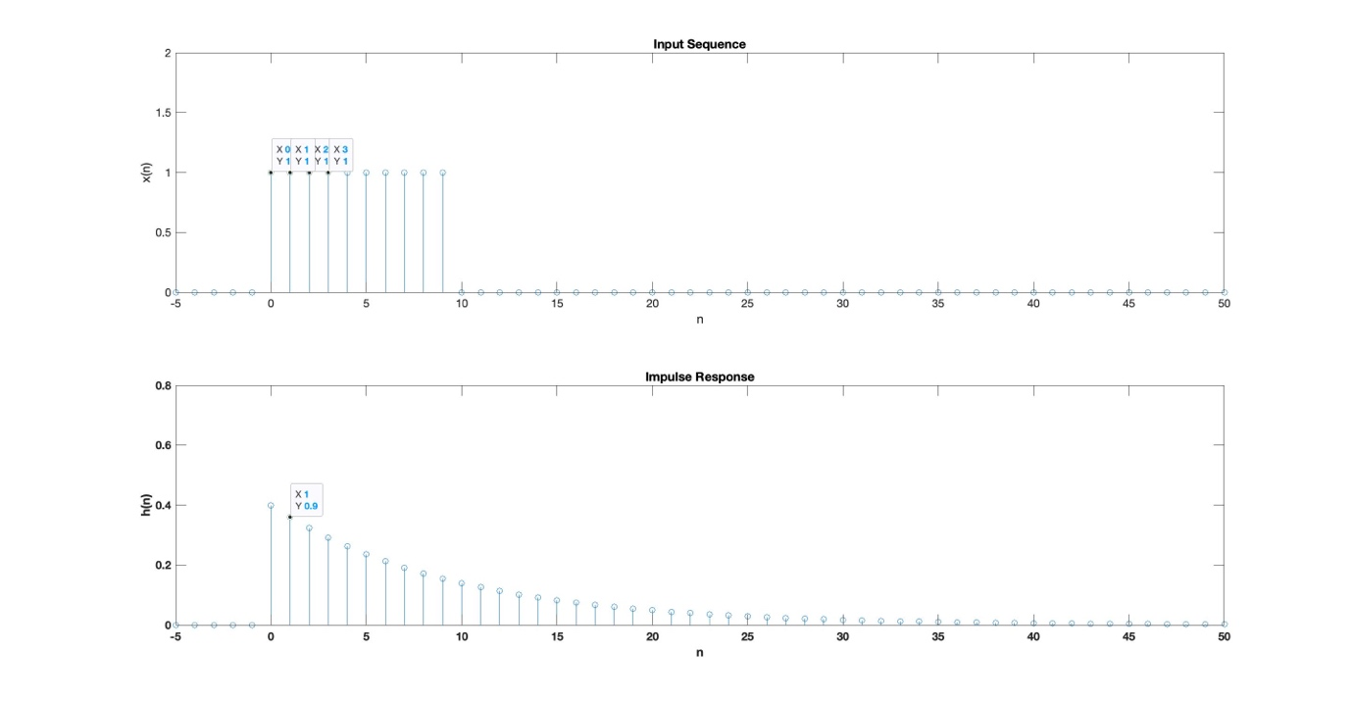

**Experiment No:** 09 [Example 2.6]

**Name of Experiment:** Give the following two sequences

|  |  |
| --- | --- |
| Program Code:  x = [3,11,7,0,-1,4,2];  h = [2,3,0,-5,2,1];  y = conv(x,h); | Output: |

**Experiment No:** 10 [Example 2.7]

**Name of Experiment:** Perform the convolution in Example 2.6 using the conv_m function.

|  |  |
| --- | --- |
| Program Code:  x = [3,11,7,0,-1,4,2];  nx = [-3:3];  h = [2,3,0,-5,2,1];  ny = [-1:4];  [y,ny] = conv_m(x,nx,h,ny); | Output: |

**Experiment No:** 11 [Example 2.8]

**Name of Experiment:** Cross correlation sequence. Let

|  |  |
| --- | --- |
| Program Code:  function [y,ny] = conv_m(x,nx,h,nh)  nyb = nx(1)+nh(1); nye = nx(length(x)) + nh(length(h));  ny = [nyb:nye]; y = conv(x,h);  function [y,n] = sigfold(x,n)  y = fliplr(x); n = -fliplr(n);  function [y,n] = sigadd(x1,n1,x2,n2)  n = min(min(n1),min(n2)):max(max(n1),max(n2));  y1 = zeros(1,length(n)); y2 = y1;  y1(find((n>=min(n1))&(n<=max(n1))==1))=x1;  y2(find((n>=min(n2))&(n<=max(n2))==1))=x2;  y = y1+y2;  function [y,n] = sigshift(x,m,k)  n = m+k; y = x;  %noise sequence 1  x = [3,11,7,0,-1,4,2];  nx=[-3:3];  [y,ny] = sigshift(x,nx,2);  w=randn(l,length(y));  nw=ny;  [y,ny] = sigadd(y,ny,w,nw);  [x,nx] = sigfold(x,nx);  [rxy,nrxyl = conv_m(y,ny,x,nx);  subplot(1,1,1), subplot(2,1,1);  stem(nrxy,rxy);  axis([-5,10,-50,25O]);  xlabel('lag variable 1')  ylabel('rxy');  title('Crosscorrelation: noise sequence 1'); | %noise sequence 2  x = [3, 11, 7, 0, -1, 4, 2];  nx = [-3:3];  [y,nyl= sigshift(x,nx,2);  w = randn(1,length(y));  nw = ny;  [y,ny] = sigadd(y,ny,w,nw);  [x,nx] = sigfold(x,nx);  [rxy,nrxy] = conv_m(y,ny,x,nx);  subplot(2,1,2);  stem(nrxy,rxy);  axis([-5,10,-50,250);  xlabel('lag variable 1');  ylabel('rxy');  title('Crosscorrelation: noise sequence 2'); |

Output:

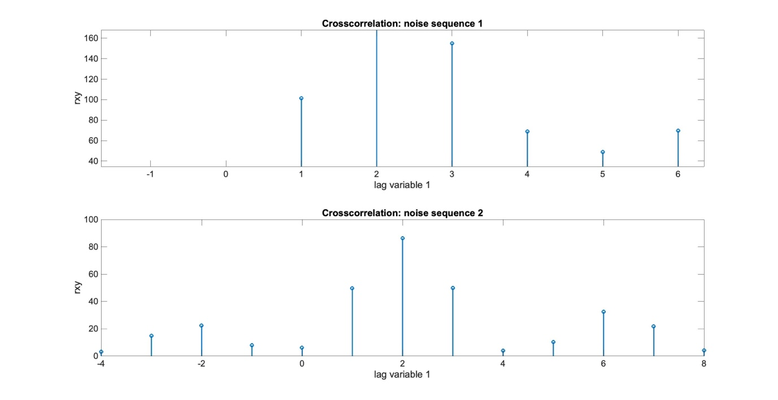

**Experiment No:** 12 [Example 2.9 (a, b)]

**Name of Experiment:** Given the following difference equation

1. Calculate and plot the impulse response
2. Calculate and Plot the unit step sequence response

|  |  |
| --- | --- |
| Program Code 2.9(a):  function [x,n] = impseq(n0,n1,n2)  n = [n1:n2]; x = [(n-n0) == 0];  b = [1];  a = [1,-1,0.9];  x = impseq(0,-20,120);  n = [-20:120];  h = filter(b,a,x);  subplot(2,1,1);  stem(n,h);  title('Impulse Response');  xlabel('n');  ylabel('h(n)'); | Program Code 2.9(b):  function [x,n] = stepseq(n0,n1,n2)  n = [n1:n2]; x = [(n-n0) >= 0];  x = stepseq(0,-20,120);  s = filter(b,a,x);  subplot(2,1,2);  stem(n,s);  title('Step Response');  xlabel('n');  ylabel('s(n)'); |

Output:

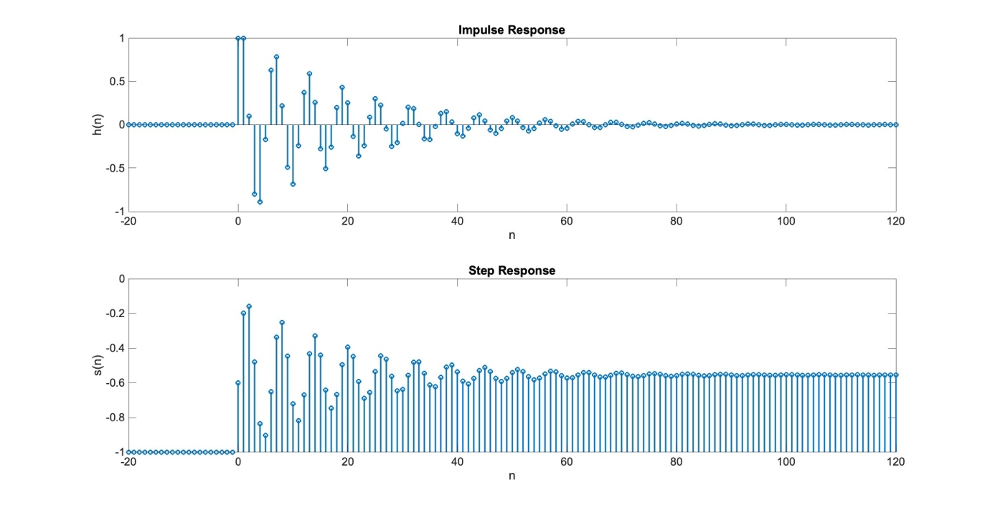

**Experiment No:** 13 [Example 2.10]

**Name of Experiment:** Let us consider the convolution given in Example 2.5. The input sequence is of finite duration. . While the impulse response is of infinite duration.

Determine

|  |  |
| --- | --- |
| Program Code:  function [x,n] = stepseq(n0,n1,n2)  n = [n1:n2]; x = [(n-n0) >= 0];  b = [1];  a = [1,-0.9];  n = -5:50;  x = stepseq(0,-5,50) - stepseq(10,-5,50);  y = filter(b,a,x);  subplot(1,1,1);  subplot(2,1,2); | stem(n,y);  title('Output Sequence');  xlabel('n');  ylabel('y(n)');  axis([-5,50,-0.5,8]); |

Output:

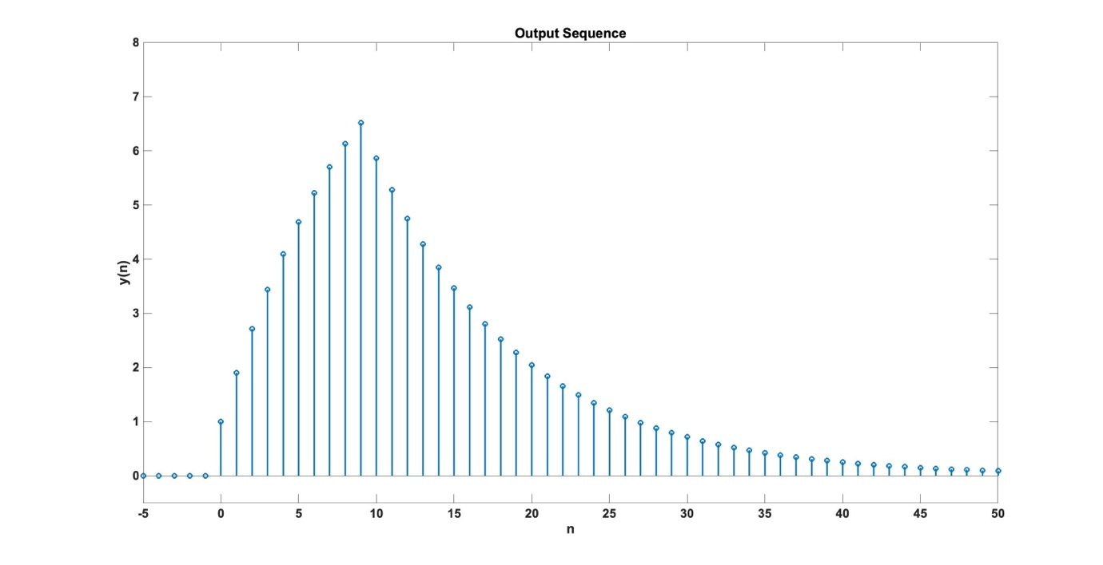

**Experiment No:** 14

**Name of Experiment:** Linear Convolution.

|  |  |
| --- | --- |
| Program Code:  function[y] = linearconvulation(x,h)  n1 = length(x);  n2 = length(h);  N = (n1+n2) - 1;  x1 = [x zeros(1, N-n1)];  h1 = [h zeros(1, N-n2)];  for n = 1:N  for m = 1:N  if n>m  H(m,n) = 0;  else  H(m,n) = h1(m - (n-1));  end  end  end  y = H * x1';  end | clc;  clear;  close all;  x = [3,11,7,0,-1,4,2];  h = [2,3,0,-5,2,1];  [linearoutput] = linearconvulation(x,h);  figure(1);  plot(linearoutput); |

Output:

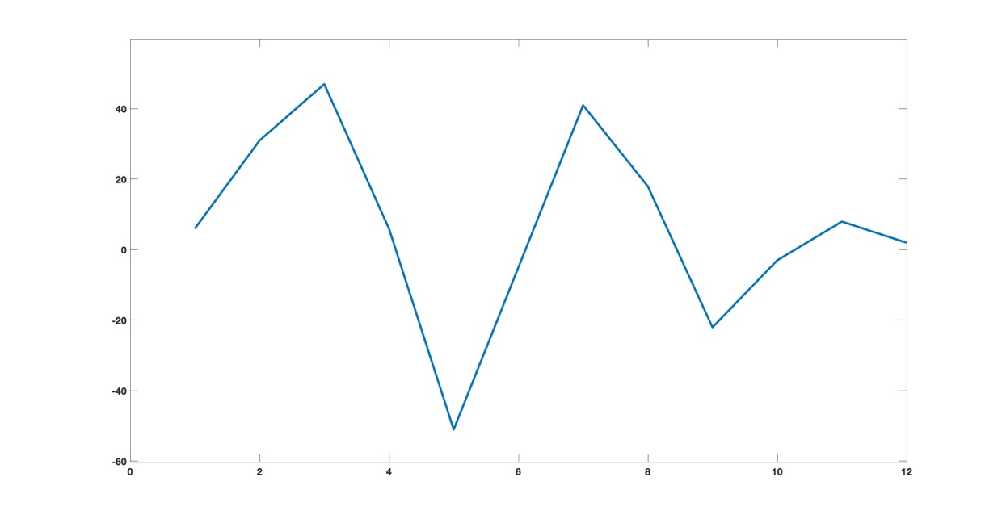

**Experiment No:** 15

**Name of Experiment:** Circular Convolution.

|  |  |
| --- | --- |
| Program Code:  function[z] = circularconvulation(x1,x2)  n1 = length(x1);  n2 = length(x2);  N = max(n1,n2);  x1 = [x1 zeros(1, N-n1)];  x2 = [x2 zeros(1, N-n2)];  s = n1 - n2;  if(s==0)  x2 = [x2 zeros(1,s)];  else  x1 = [x1 zeros(1,-s)];  x2 = [x2 zeros(1,s)];  end  %circular multiplication  z = [];  for k = 1:N  y = 0;  for i = 1:N  j = (k-i) + 1;  if(j<=0)  j = j + N;  end  y = y + (x1(i) * x2(j));  end  z = [z,y];  end  end | clc;  clear;  close all;  x = [3,11,7,0,-1,4,2];  h = [2,3,0,-5,2,1];  [circularoutput] = circularconvulation(x,h);  figure(1);  plot(circularoutput); |

Output:

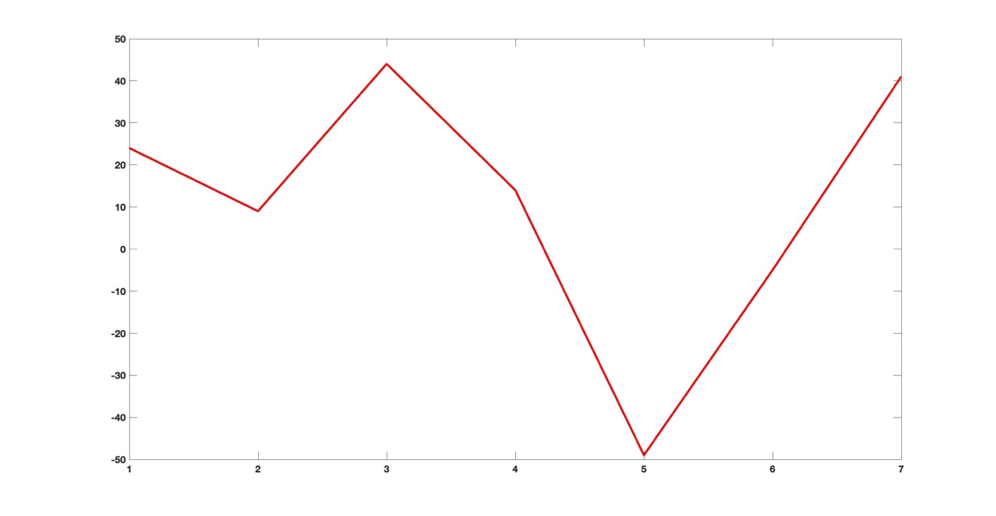

**Experiment No:** 16 [Problem 2.1(a)]

**Name of Experiment:**

|  |  |
| --- | --- |
| Program Code:  function [x,n] = impseq(n0,n1,n2)  n = [n1:n2]; x = [(n-n0) == 0];  clc;  clear;  close all;  n1 = [0:25];  x1 = zeros(1,length(n1));  for m = 0:10  x1 = x1 + (m+1)*(impseq(2*m,0,25) - impseq(2*m+1,0,25));  end  stem(n1,x1);  xlabel('n');  ylabel('x1(n)');  title('Sequence x1(n)'); | Output: |

**Experiment No:** 17 [Problem 2.1(b)]

**Name of Experiment:**

|  |  |
| --- | --- |
| Program Code:  function [x,n] = impseq(n0,n1,n2)  n = [n1:n2]; x = [(n-n0) == 0];  function [x,n] = stepseq(n0,n1,n2)  n = [n1:n2]; x = [(n-n0) >= 0];  clc;  clear;  close all;  n2 = -5:10;  x2 = (n2.^2).*(stepseq(-5,-5,10)-stepseq(6,-5,10))+10*impseq(0,-5,10)+20*((0.5).^n2).*(stepseq(4,-5,10)-stepseq(10,-5,10));  stem(n2,x2);  xlabel('n');  ylabel('x1(n)');  title('Sequence x2(n)'); | Output: |

**Experiment No:** 18 [Problem 2.1(c)]

**Name of Experiment:**

|  |  |
| --- | --- |
| Program Code:  clc;  clear;  close all;  n3 = [0:20];  x3 = ((0.9).^n3).*cos(0.2*pi*n3+pi/3);  stem(n3,x3);  xlabel('n');  ylabel('x3(n)');  title('Sequence x3(n)'); | Output: |

**Experiment No:** 19 [Problem 2.1(d)]

**Name of Experiment:**

|  |  |
| --- | --- |
| Program Code:  clc;  clear;  close all;  w = 2*(rand(1,101)-0.5);  n4 = [0:100];  x4 = 10*cos(0.0008*pi*n4.^2)+w;  stem(n4,x4);  xlabel('n');  ylabel('x4(n)');  title('Sequence x4(n)'); | Output: |

**Experiment No:** 20 [Problem 2.1(e)]

**Name of Experiment:**

|  |  |
| --- | --- |
| Program Code:  clc;  clear;  close all;  n5 = [-8:11];  x5 = [2,1,2,3];  x5 = x5'*ones(1,5);  x5 = (x5(:))';  stem(n5,x5);  xlabel('n');  ylabel('x5(n)');  title('Sequence x5(n)'); | Output: |

**Experiment No:** 21 [Problem 2.2(a)]

**Name of Experiment:** Let

|  |  |
| --- | --- |
| Program Code:  function [y,n] = sigshift(x,m,k)  n = m+k; y = x;  function [y,n] = sigadd(x1,n1,x2,n2)  n = min(min(n1),min(n2)):max(max(n1),max(n2));  y1 = zeros(1,length(n)); y2 = y1;  y1(find((n>=min(n1))&(n<=max(n1))==1))=x1;  y2(find((n>=min(n2))&(n<=max(n2))==1))=x2;  y = y1+y2;  n = [-4:2];  x = [1,-2,4,6,-5,8,10];  [x11,n11] = sigshift(3*x,n,-2);  [x12,n12] = sigshift(x,n,4);  [x13,n13] = sigadd(x11,n11,x12,n12);  [x1,n1] = sigadd(x13,n13,2*x,n);  stem(n1,x1);  xlabel('n');  ylabel('x1(n)');  title('Sequence x1(n)'); | Output: |

**Experiment No:** 22 [Problem 2.2(b)]

**Name of Experiment:** Let

|  |  |
| --- | --- |
| Program Code:  function [y,n] = sigshift(x,m,k)  n = m+k; y = x;  function [y,n] = sigadd(x1,n1,x2,n2)  n = min(min(n1),min(n2)):max(max(n1),max(n2));  y1 = zeros(1,length(n)); y2 = y1;  y1(find((n>=min(n1))&(n<=max(n1))==1))=x1;  y2(find((n>=min(n2))&(n<=max(n2))==1))=x2;  y = y1+y2;  n = [-4:2];  x = [1,-2,4,6,-5,8,10];  [x21,n21] = sigshift(5*x,n,-5);  [x22,n22] = sigshift(4*x,n,-4);  [x23,n23] = sigadd(x21,n21,x22,n22);  [x2,n2] = sigadd(x23,n23,3*x,n);  stem(n2,x2);  xlabel('n');  ylabel('x2(n)');  title('Sequence x2(n)'); | Output: |

**Experiment No:** 23 [Problem 2.2(c)]

**Name of Experiment:** Let

|  |  |
| --- | --- |
| Program Code:  function [y,n] = sigshift(x,m,k)  n = m+k; y = x;  function [y,n] = sigadd(x1,n1,x2,n2)  n = min(min(n1),min(n2)):max(max(n1),max(n2));  y1 = zeros(1,length(n)); y2 = y1;  y1(find((n>=min(n1))&(n<=max(n1))==1))=x1;  y2(find((n>=min(n2))&(n<=max(n2))==1))=x2;  y = y1+y2;  function [y,n] = sigmult(x1,n1,x2,n2)  n = min(min(n1),min(n2)):max(max(n1),max(n2));  y1 = zeros(1,length(n)); y2 = y1;  y1(find((n>=min(n1))&(n<=max(n1))==1))=x1;  y2(find((n>=min(n2))&(n<=max(n2))==1))=x2;  y = y1 .* y2;  function [y,n] = sigfold(x,n)  y = fliplr(x); n = -fliplr(n); | n = [-4:2];  x = [1,-2,4,6,-5,8,10];  [x31,n31] = sigshift(x,n,-4);  [x32,n32] = sigshift(x,n,1);  [x33,n33] = sigmult(x31,n31,x32,n32);  [x34,n34] = sigfold(x,n);  [x34,n34] = sigshift(x34,n34,2);  [x34,n34] = sigmult(x34,n34,x,n);  [x3,n3] = sigadd(x33,n33,x34,n34);  stem(n3,x3);  xlabel('n');  ylabel('x3(n)');  title('Sequence x3(n)'); |

Output:

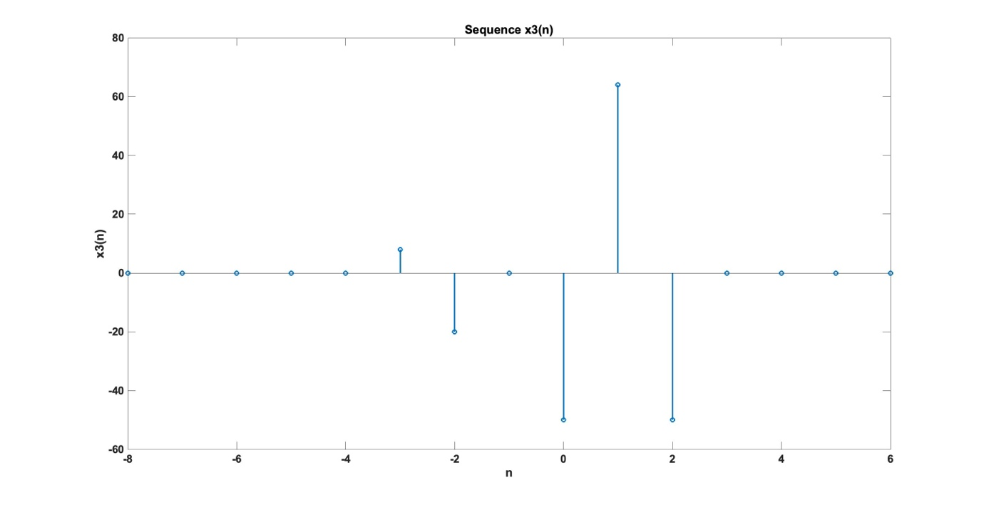

**Experiment No:** 24 [Problem 2.2(d)]

**Name of Experiment:** Let

|  |  |
| --- | --- |
| Program Code:  function [y,n] = sigshift(x,m,k)  n = m+k; y = x;  function [y,n] = sigadd(x1,n1,x2,n2)  n = min(min(n1),min(n2)):max(max(n1),max(n2));  y1 = zeros(1,length(n)); y2 = y1;  y1(find((n>=min(n1))&(n<=max(n1))==1))=x1;  y2(find((n>=min(n2))&(n<=max(n2))==1))=x2;  y = y1+y2;  function [y,n] = sigmult(x1,n1,x2,n2)  n = min(min(n1),min(n2)):max(max(n1),max(n2));  y1 = zeros(1,length(n)); y2 = y1;  y1(find((n>=min(n1))&(n<=max(n1))==1))=x1;  y2(find((n>=min(n2))&(n<=max(n2))==1))=x2;  y = y1 .* y2;  n4 = [-10:10];  n = [-4:2];  x = [1,-2,4,6,-5,8,10];  x41 = 2*exp(0.5*n4);  x412 = cos(0.1*pi*n4);  [x42,n42] = sigmult(x41,n4,x,n);  [x43,n43] = sigshift(x,n,-2);  [x44,n44] = sigmult(x412,n4,x43,n43);  [x4,n4] = sigadd(x42,n42,x44,n44);  stem(n4,x4);  xlabel('n');  ylabel('x4(n)');  title('Sequence x4(n)'); | Output: |

**Experiment No:** 25 [Problem 2.2(e)]

**Name of Experiment:** Let

|  |  |
| --- | --- |
| Program Code:  function [y,n] = sigshift(x,m,k)  n = m+k; y = x;  function [y,n] = sigadd(x1,n1,x2,n2)  n = min(min(n1),min(n2)):max(max(n1),max(n2));  y1 = zeros(1,length(n)); y2 = y1;  y1(find((n>=min(n1))&(n<=max(n1))==1))=x1;  y2(find((n>=min(n2))&(n<=max(n2))==1))=x2;  y = y1+y2;  function [y,n] = sigmult(x1,n1,x2,n2)  n = min(min(n1),min(n2)):max(max(n1),max(n2));  y1 = zeros(1,length(n)); y2 = y1;  y1(find((n>=min(n1))&(n<=max(n1))==1))=x1;  y2(find((n>=min(n2))&(n<=max(n2))==1))=x2;  y = y1 .* y2; | n = [-4:2];  x = [1,-2,4,6,-5,8,10];  [x51,n51] = sigshift(x,n,1);  [x52,n52] = sigshift(x,n,2);  [x5,n5] = sigadd(x51,n51,x52,n52);  [x53,n53] = sigshift(x,n,3);  [x5,n5] = sigadd(x5,n5,x53,n53);  [x54,n54] = sigshift(x,n,4);  [x5,n5] = sigadd(x5,n5,x54,n54);  [x55,n55] = sigshift(x,n,5);  [x5,n5] = sigadd(x5,n5,x55,n55);  [x5,n5] = sigmult(x5,n5,n5,n5);  stem(n5,x5);  xlabel('n');  ylabel('x5(n)');  title('Sequence x5(n)'); |

Output:

